#### HANDS Dissemination

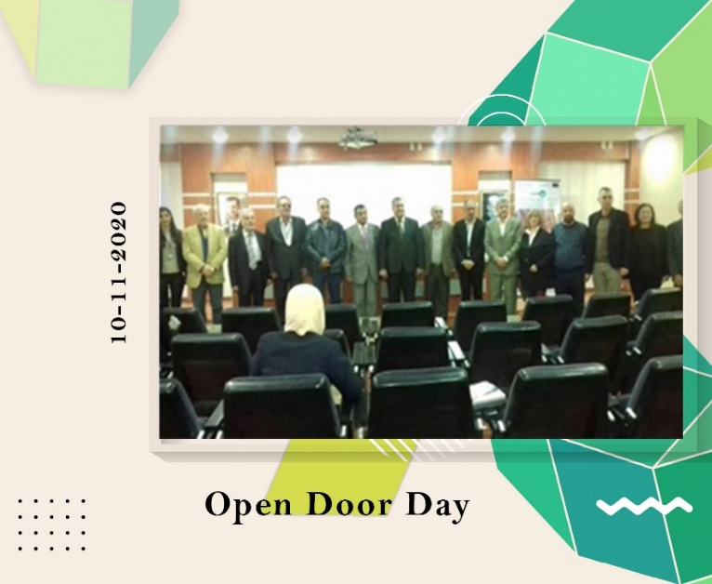**HANDS Dissemination at ABU: Erasmus+ day event in ABU**

**WP 8: DISSEMINATION & EXPLOITATION**

**Date:** Tuesday, 10/11/2020  
**Organizer:** AlBaath University ABU  
**Location:** Faculty of architecture / Blue seminar room

Al-Baath University (Syria) hosted a HANDS Project Information Day and Open Door Day, announcing a dedicated office in the Faculty of Architecture. Prof. Satouf presented on traditional Damascene crafts, and Prof. Al Samara emphasized the project's importance for Syria and Jordan. The university president praised the collaboration with partners, marking a successful event.